A000-Am,C-Celt-Anthropomorphic Cemi with ear spools, Sun Disk Headdress-Basalt-1000 CE



Am,C-Celt-Anthropomorphic Cemi with ear spools, Sun Disk Headdress-Basalt-1000 CE

**Case No.:**

**Accession No.**

**Formal Label:** Am,C-Celt-Anthropomorphic Cemi with ear spools, Sun Disk Headdress-Basalt-1000 CE

**Display Description:**

This Basalt Anthropomorphic Celt represents a spirit who is intermediary between the Sun and the Tainos. In ceremonies it was held by the hafting just below the chin of the cemi.

**LC Classification: F 1909**

**Date or Time Horizon: 1000 CE**

**Geographical Area: Caribbean, Classic Taino Area**

**Map:**

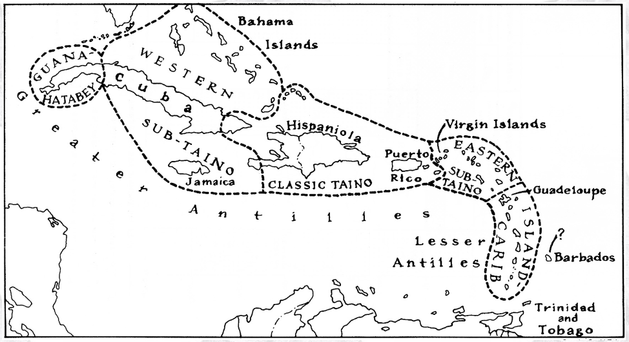

**Caribbean c 1500 after http://www.latinamericanstudies.org/maps/Ciboney-Taino-Carib-map.jpg**

**GPS coordinates:**

**Cultural Affiliation:**

**Media:**

**Dimensions:**

**Weight:**

**Condition:**

**Provenance:**

**Discussion:**

**References:**